Note – All bytes with 8 bits are LSB first

Wait for RPLY: 119 (vsync trigger)

PC: 245 (telling it’s starting, possibly reset)

PC: 000xxxxx (000, a, b, x, y, dpadL)

PC : 001xxxxx(001, dpadR, dpadU, dpadD, L, R)

PC : 010xxxxx(010, start, select, lid, touchPen, PWR)

RPLY: 2

(PC sends all 3 bytes, waits to ensure that all three were received)

PC: 255 (Reset)

PC: 000xxxxxx(000, x1-5)

PC: 001xxxxxx(001, x6-10)

PC: 010xxxxy(010, x11-15)

PC: 011yyyyy(011, y1-5)

PC: 100yyyyy(100, y6-10)

PC: 101yyyyy(101, y11-15)

PC: 255

RPLY: 0 if all were received, else ID of missing msg

Total – 18 bytes ideal situation (144 bits)

Baudrate is 115200=1920 bits per frame

Approx 4000 microseconds (4 milliseconds) between touchscreen polls in most configs, 3-4 between sub-polls (actually looks like we have enough time)

54 messages send only takes about 3000 microseconds – probably the safest max

Need to run at full USB speed to work fine, figure out how to support that, or work off of SD

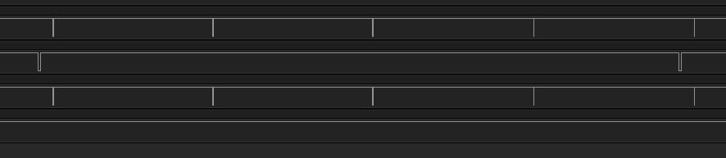

Sync vs. touchscreen polls.

After first poll, asap update touchscreen and button pins (around .25 milliseconds to do so)

Between polls we can update the buffer

Polls per frame:

* Mario 64 DS – 4 – Nov 2004
* Cooking Mama 2 – 4 – Nov 2007
* NSMB – 4 – May 2006
* Mariokart – 4 – Nov 2005
* Pictionary – 4
* Scribblenauts – 4 – Sep 2009
* Super Scribblenauts – 4 – Oct 2010
* Namco Museum DS - 4
* Mario party -1 w/ no loads – Nov 2007
* Pokemon Black – 1 w/ no loads – Sep 2010
* Cars 2 – 1 constantly (limited testing)
* Phineas and Ferb Ride Again – 1 constantly most of the time (seems to be a bit random when loading)
* Phineas and Ferb Across the 2nd Dimension – 1 w/ no loads
* Uno Skip Bo Uno Free Fall – 1 w/ no loads
* Diddy kong racing DS – every other frame – Feb 2007
* Pokemon soulsilver – every other frame – Sep 2009
* Pokemon platinum – every other frame – Sep 2008
* Band Hero – every other frame
* My Sims Agents – every other frame
* Plants vs. Zombies – every other frame
* Flash card – 9 per frame with the occasional 251?
* Touch test – 1 when pressed, 0 when not
* Lego lord of the rings – 2
* Lego harry potter years 1-4 – 2
* Lego harry potter years 5-7 – 2
* Lego batman – 2
* Lego star wars the complete saga – 2
* Call of Duty modern warfare mobilized - 2
* Big brain academy – 3 (only tested title screen though)
* My sims – 1 most frames on title screen, then every other frame???